**Case Study Analysis of**

**Connor Formed Metal Products**

CIS 410-50

Ben Lascurain

4/13/2019

**Executive Summary**

Connor Formed Metal Products, which was later renamed Connor Springs (referred to as Connor from here forward) is a company that is on verge of becoming an industry leader in metal stampings, wire forms, assemblies, and metal springs. The main challenge holding them back is the change they must implement company wide.

Connor has four manufacturing locations; San Jose, Dallas, Los Angeles, and Portland. Connor is struggling to improve its bottom line even though their shipments rose from under $8 million in 1982 to greater than $17 million. With the Dallas and Los Angeles locations being the worst performers, Sloss (the President), decides to take a chance by hiring Michael Quarrey as Connor’s HR manager and working to improve employee ownership by writing custom software.

The Los Angeles plant was chosen as to implement a new custom software because it was very low performing and it was the largest plant, making communication and data availability imperative. After implementing the software through a few cycles of development and feedback, the L.A. plant saw a major turn-around. Their productivity rose due to the ability to see the entire history of an order on the screen without sifting through carbon copies. Also, any issues could be immediately shared to the needed departments decreasing communication times.

This information flow also gave the floor workers the ability to demand the attention of the office on an order and make the necessary adjustments real time. This also improved other points of the ordering process because of the ease of locating orders, communication between departments, and the usability of the software by even the most novice computer users. The value gained by utilizing the system has now put pressure on Sloss to impose the system on the other three locations.

Portland seems enthusiastic about the change and *pulling* for the change to come to their location. Dallas will likely request the changes as well because it is a newer organization after merging Phoenix and the old Dallas plant together. Dallas isn’t likely to be set in their ways and resistant to change especially since the workers know that failure to keep up the bottom line forced their reformation once already. The real challenge will be how to deal with San Jose.

San Jose is the top performer. San Jose has 60 employees compared to the 100 at the L.A. plant. They specialize in manufacturing of short run prototypes for high-tech companies. Their manager, Petty, is known for his bottom-line approach and because of this it has record profit margins. This alone could serve as a reason to resist the new order management system created by Quarrey, but on top of this the workers at San Jose don’t even use their current IBM System 36 information system because of the comfort level of the users.

The challenge will be having the San Jose plant voluntarily “pull” for the new system by means of education and communication. Through educating and communicating how easy the system is to use from their peers (L.A.), the reluctant workers of San Jose, a high functioning plant can become a power house of the industry. They should not reject change because they are doing well, there is room for improvement. The way to implement this change is not by force, but by demonstration and education.

**SWOT analysis of Connor**

**Strengths**: Connor has historically not had any debts. With their new president, Sloss, Connor has shifted its business to a differentiation model through superior service. This superior service is enabled by the new order management system. Connor has also established statistical process control systems and begun to hire engineers. Shipments are rising by more than 100% between 1982 and 1988. The new order management system developed by Quarrey offers a unique opportunity of eliminating large chunks of time that would otherwise be required in the product development process.

**Weaknesses**:Connor has typically been slow growth, and not quick to change. The changes implemented by Sloss since his presidency are rather large, and may be viewed as too much by veterans of the company who have seen success through old methodologies.

**Opportunities**: other metal stamping and forming companies are notorious for their poor customer service and therefore compete through price. Connor can differentiate their product by offering superior customer service through the new order management system. This system allows quick order recall and history during customer call ins. Customers already have proved that they will pay more because of the quality of service. This can increase the bottom line with nearly no additional cost through increasing margins. The challenge will be adopting the technology at San Jose, Portland, and Dallas.

**Threats**: External threats are other metal manufacturers. They can acquire similar technology making them just as capable of providing great customer service. Currently Connor should act by acquiring as many loyal customers as they can while they are the only companies with such an order management system.

**Introduction to the Los Angeles Experiment**

The Los Angeles experiment started for a couple of reasons. One being that Sloss saw the need for efficiency and automation by using computers. Another reason was because the Los Angeles plant was the worst performing plant of all and was the largest as well. This made drastic measures easier to accept by the workers because they knew they needed the change.

The new system was developed by Quarrey, but a significant contribution came from an opinionated machinist, Roy Gallucci. Roy basically said that he wants one of his biggest issues with the current system addressed in the new system. He wants the ability for the shop floor workers to put a hold on an order without restriction. This will require the office workers to acknowledge their concerns and work out a resolution before proceeding.

This point is important because it explains why the Los Angeles workers so readily adopted the technology. They were heard and were part of the process of implementing change. They became vested. Through the chart below we see that the approach of “Participation + Involvement” was used. This approach was used because the designer didn’t have all the necessary knowledge of the process to implement the change and the floor workers had considerable power in resisting the change if they 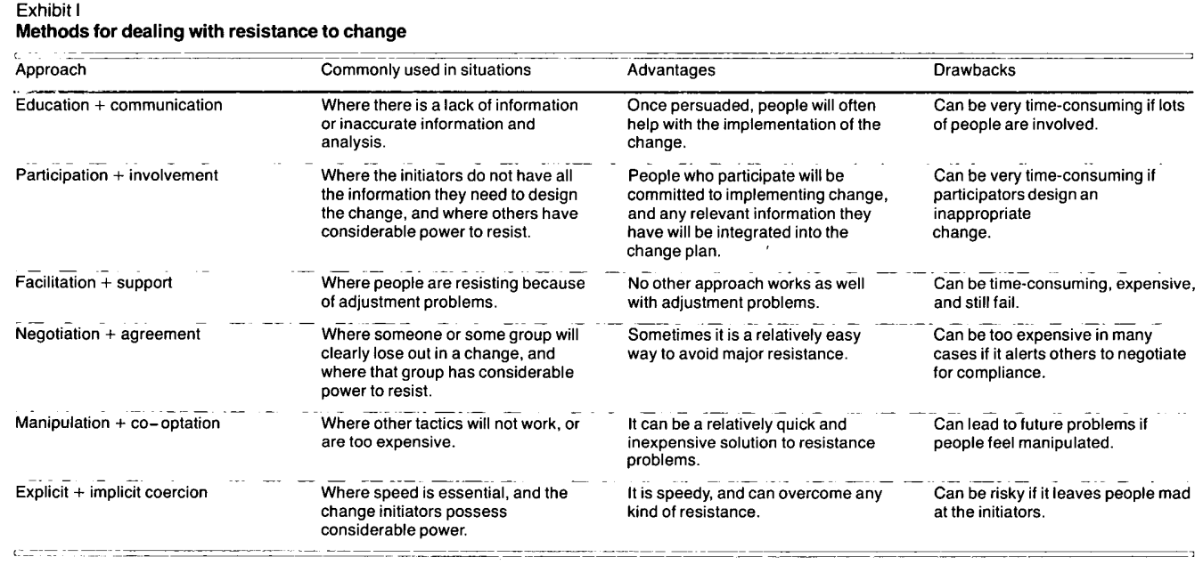chose.

**Strategies for Change, Kotter and Schlesinger - pp. 111**

Since Quarrey used the appropriate technique to get the workers of the Los Angeles plant to adopt the change, the workers began to really appreciate what they could do with the software. They appreciate it even more because they felt like their voices were heard and they understood the value of the change.

*“...be aware of the four most common reasons people resist change. These include: a desire not to lose something of value, a misunderstanding of the change and its implications, a belief that the change does not make sense for the organization, and a low tolerance for change.”*

**Strategies for Change, Kotter and Schlesinger - pp. 107**

The results of the system were facility wide. Each department benefited from use of the system so adoption was easy. Each department saw value that was greater than the work it took to learn a new system.

* The floor workers were empowered to control the process and stop work until their concerns were met.
* Engineers could perform estimates within minutes when it used to take an hour.
* Customer service representatives eliminated the use of carbon copies and had e-records that were instantly retrievable when speaking with a customer over the phone.
* Sales people began doing all their communication of customer needs electronically instead of phone calls and handwritten reports.

Each department saw clear benefits, so each department at the L.A. plant quickly and emphatically adopted the changes.

**Next Steps for Portland, Dallas, and San Jose**

Although the technology worked wonders at the Los Angeles plant, we cannot assume that the other three will instantly drop their current ways of doing things in favor of the new system. Each of these locations must choose to adopt the system by one approach of adoption or another. The important thing to notice here is that each location can and should be treated as a different organization even though they all are part of the same company.

**Portland**

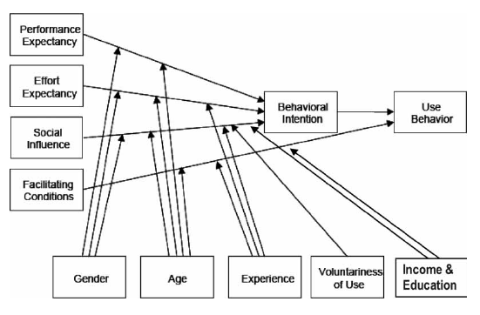Portland is one of the two locations that is using the IBM System 36. The workers in Portland dislike their system and openly admit that they hate the systems complexity and inability to work for the custom orders that require estimations. Portland is a prime candidate to adopt the system because many of its workers are comfortable with using computer systems, but do not like the IBM system. They would mean little effort expectancy, good facilitating conditions at the plant, and high-performance expectancy.

These points of technology acceptance are diagramed to the left, and help explain the positive factors of why Portland would use the system developed by Quarrey.

Portland’s workers are very familiar with computer systems, so it is reasonable to assume that they would have no issues learning and adapting to the new system.

**Dallas**

Dallas is the newest plant of the four plants. It was reformed after the Phoenix location failed and was merged in with the old Dallas plant at new location. The workers at Dallas understand the repercussions of failing to meet the bottom line. Many of the workers were transferred there and know first hand the importance of performance.

There is no indication that the Dallas plant would choose not to adopt the technology. There was no mention of user familiarity with computers or their ability to perform their tasks exclusively with a computer. The workers at the Dallas location would not likely resist the change, especially after seeing the positive results that Los Angeles had. The fear of another re-org is likely much greater than the fear of adopting a new technology that is proven to lead to success.

*“...concern for the ability of organizations to respond to environmental change. As one person wrote: "It follows that an acceleration in the rate of change will result in an increasing need for reorganization. Reorganization is usually feared, because it means disturbance of the status quo, a threat to people's vested interests in their jobs, and an upset to established ways of doing things. For these reasons, needed reorganization is often deferred, with a resulting loss in effectiveness and an increase in costs.”*

**Strategies for Change, Kotter and Schlesinger - pp. 106**

Anything to keep the plant from being closed down again would be motivation enough, and this software would likely be pulled into the organization without Sloss needing to “push” it onto them.

**San Jose**

San Jose is where the resistance for system adoption will be strongest. Careful thought should be given to San Jose’s situation, and why their managers have expressed that they do not want the system. Once the real underlying reasons of resisting the new order management system are discovered, they can be dealt with appropriately.

*“Because of the many different ways in which individuals and groups can react to change, correct assessments are often not intuitively obvious and require careful thought.”* **Strategies for Change, Kotter and Schlesinger - pp. 107**

San Jose is managed by someone who is known for efficiency and the bottom line. They are far and away the most productive plant and have a sense of superiority. They feel entitled to make decisions on how to run their operations because they have, so far, been the most successful at running operations. This creates a sense of disaffiliation from the other Connor locations, coupled with egocentrism. Afterall, why should the top performing company take marching orders just because a new system was successfully implemented elsewhere. San Jose has been successful all along.

*“Egocentric organizations draw boundaries around narrow definitions of themselves and attempt to advance the self-interest of this narrow domain. Part of the problem rests in the very idea of what it means to be ‘an organization.’ The concept implies an entity, ‘a thing,’ something with a discrete existence.”*

**Morgan, pp. 250**

San Jose sees itself as a superior entity to the rest of the plants, and to make matters worse the workers have multiple negative factors from the Technology Acceptance Model. These negative factors are:

* **The perceived effort expectancy** – San Jose workers are not skilled computer users and would be uncomfortable performing all their process management tasks on a computer.
* **The performance expectancy** – The perceived performance enhancement is not there for these workers. They believe that they are already working at an optimal level and that any changes would only hinder their ‘optimized’ productivity (especially when they don’t feel comfortable with computers).
* **Age and Gender** – The majority of the workers in these machinist positions could be assumed to be male (this isn’t sexist, this is a logical assumption). Males are known to be less adaptive than women, and acceptance of change would also be negatively correlated with acceptance of change.
* **Experience** – the longer these workers have been with company the less likely they would embrace changes because they have become accustomed to performing their duties a certain way. They will likely attribute their success to the methods they have always used.

As the factors from the technology acceptance model show, the user’s likelihood to accept the technology is influenced by multiple factors, and each of these negative factors are present (at least some degree) at the San Jose location.

These are powerful forces of resistance to this new system. It will be imperative for the Connor execs, Sloss and Quarrey, to be mindful of these factors that are influencing the San Jose workers to be resistant the new order management system.

*“... the ability of a system to engage in self-regulating behavior depends on processes of information exchange involving negative feedback.”*

**Morgan, pp. 82**

**Decision**

This system will need to adopted by each of the four manufacturing plants, but the way in which this adopting occurs will vary across the three remaining plants. Each situation is different and needs a different approach. It goes without saying that Los Angeles has already adopted the system and wouldn’t want to do without the system.

**Portland:** To get Portland on board with the new system will not be an issue because the users constantly complain about, he current system and would love to have different system. The users are technologically capable and comfortable with computers and wouldn’t see adoption of the new order management system as a significant effort, especially considering the possible benefits. They have expressed excitement in getting rid of the old IBM System 36.

**Dallas:** With a recent re-org fresh on the mind of many of the displaced Phoenix workers they understand that any change that promises a better bottom line should be accepted. They know that in order to avoid having their plant shut down they need to have the numbers to justify this. The Dallas workers know of the success that L.A. had with implementing their system and would likely be eager to implement it in Dallas. There aren’t any obvious impediments such as workers not being familiar with computers, so implementation should be easy.

**San Jose:** This is the only location that would face any serious opposition. In one of the meetings a San Jose manager mentioned that San Jose and Portland already had state of the art systems and wouldn’t need a new system. This is an attempt to build support by trying to build the impression of support by saying Portland has the same view. Portland obviously disagrees, as expressed in their excitement to adopt the system.

Workers at San Jose says they already have a computer system, but they fail to mention that they don’t even utilize because they the workers there are not comfortable working on a computer (effort expectancy).

To make matters worse the perceived performance enhancement is not there for these workers. They believe that they are already working at an optimal level and that any changes would only hinder their ‘optimized’ productivity (especially when they don’t feel comfortable with computers).

**San Jose Solution:** the solution to having San Jose adopt the new order process management system is to **educate and communicate** with the workers as they adopt the new system. First without saying they will have to adopt the system, take a large group from San Jose that is representative of the varying levels of employees from various departments to the L.A. plant.

Take them to work alongside their L.A. counterparts to see the new process. Allow them to talk to workers of their same position so they can see how easy the system is. Allow them to see how simple the system is. Allow other machinists to teach them so that they do not feel inferior. This should alleviate issues they have with their perception of the effort required.

Furthermore, by having some of the workers shadow operations at the L.A. facility, they can gain a sense of envy of the system. How easy it is to get the attention of office workers when they have an issue with the process. How easy it is to locate and edit orders. How the entire record of an order is at the click of key. Do not force them to choose this, but rather give them the opportunity to change their mind about adopting the new system by communicating and educating their workers.

After San Jose workers shadow at the L.A. location it is likely that they will no longer think adopting the system will be difficult and that the benefits are obviously desirable.

**Rejected Alternatives**

1. **Force The change:**  this was rejected because the change isn’t needed to be immediate, and would likely result in serious resistance and tension.
2. **facilitate and support:** this option was rejected because the issue with San Jose isn’t with there being a lack support for the new system, but rather the issue is that they perceive the system being to complex and difficult to use. This isn’t to say that no facilitation or training should be had, but that the initial step of getting San Jose to accept the new system relies on educating them on the benefits and ease of use from their peers.
3. **Negotiation and Agreement:** Negotiating with the San Jose plant to adopt the change is best only in cases where someone clearly loses out and this is not the case.
4. **Manipulation and co-optation:** this methodology was not chosen because it should be used as one of the last available options. It can cost relationships between the organization if they find out they have been manipulated into adopting the technology.
5. **Coercion:** this was not chosen because it should only be used when speed is essential and the change is more important than keeping happy employees. San Jose is a productive plant as it is and doesn’t need immediate intervention.